Thesis Title page

Abstract
In this Note, some indications on how to write a Thesis (both for a Bachelor's and Master's Degree) are provided. The indications provided largely disregard both the “content” and the “writing style” of the document. They rather concern issues such as (for example) the choice of font for the body text and titles, page layout, writing standards for equations, the arrangement of figures, tables and captions, and the citation of references.
The text is written according to the guidelines that must be adopted to write the Thesis, therefore viewing it can provide an indication of the layout that you need for your Thesis. In this regard, we advise you to print this Note double-sided, so that you get a document with an overall graphical appearance that is similar to that of your Thesis.

Declaration of usage of generative AI and AI-assisted technologies
(choose between options A or B, then add the following accountability statement)

A) No generative AI and AI-assisted technologies were used to perform this project and to write the Thesis.
B) If AI or AI-assisted technologies were used, the student is required to describe any use of them, e.g.:
- executing parts of the project (including coding)
- interpreting results
- reviewing scientific and technical literature
- drawing plots and pictures
- writing text
- etc.
The author reviewed and edited the Thesis as needed and take full responsibility for its content.

Table of Contents
Introduction 7
Chapter 1: Writing the Thesis 3
1.1 Font to be used 3
1.1.1 Line spacing (and other issues) 3
1.1.1.1 Chapters, paragraphs and sub-paragraphs 4
1.2 Figures and tables 5
1.2.1 Let's start with figures 5
1.2.1.1 On the reproduction of results 7
1.2.2 Let's finish with the tables 7
1.3 Calculation codes 8
1.4 References 9
1.5 Page numbering and binding margins 10
1.6 Title page and final print 10
Conclusions 11
Nomenclature 13
References 15
Appendix A: Complete algorithm 17

Introduction

Use the style “Chapter Number”
The Thesis's Introduction summarises the reasons for studying a particular topic, placing them in the national and international scientific context, or taking into account the context of the company in which the study was conducted. After the reasons, the goals of the Thesis should be stated; next, information should be given on the structure of the Thesis, briefly indicating the number of Chapters and the content of each Chapter. Normally, the Introduction is not very long (a couple of pages are usually enough), but we invite you to check with your supervisor for more specific guidance.
Please note that the Thesis includes the Introduction, therefore the Introduction appears in the Table of Contents. However, a Summary of the Thesis must be included before the Table of Contents. In no more than twenty lines, you are required to provide a summary of the issue that the Thesis deals with, the tools or methods used to solve it, the results achieved, and the limitations of the study. This Note consists of a single Chapter, and therefore only one Chapter will appear in the Table of Contents. A Thesis will instead consist of several Chapters, and each of them must appear in the Table of Contents under its own title.
It is worth noting that the Thesis should be written by adopting a scientific style: the first person should therefore never be used (“I conducted an analysis of the data”; “we obtained interesting results”), and a corresponding impersonal form (“an analysis was conducted”; “interesting results were obtained”) should be always preferred.

Chapter 1:
Writing the Thesis

Use the style “Chapter Title”
Normally, at the beginning of a Chapter there is a short preamble (5-6 lines) summarising the topics that will be discussed in the chapter.

1.1 Font to be used

For the text body, use the style “Normal”

This title level should be in the style “Heading 1”
The font to be used for the body text is Times New Roman, 12 points. The body text should be written in a plain font, like the one that you are reading now. Italic writing is generally used in two cases: to emphasise certain concepts, or to indicate foreign technical terms that are not currently in use in the language that you are writing in (in this case, English). In the first case, it is always preferable not to use an excessive number of italicised terms, so as not to compromise the readability of the text. As for the second case, it is best to avoid using a foreign term when it is possible to translate it with a corresponding English term.

For this title level, use the style “Heading 2”

1.1.1 Line spacing (and other issues)
Line spacing must be set exactly at 18 points, which corresponds to slightly less than 1.5 lines. Exact line spacing allows to insert an equation in the body text (as is the case when, for example, you write that 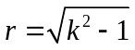) without causing mismatches between the line containing the equation and the other lines.
Speaking of equations, all equations that appear as “stand-alone”, i.e. not within the body text, must be numbered. By equations we mean both the actual mathematical formulas (equations; inequalities; etc.), but also stoichiometric equations, kinetic mechanisms and chemical formulas. The numbering of equations must be consecutive, by Chapter, and placed at the right-hand margin of the page. Consider this example, which also clarifies the spacing to be used between the body text and the equation. The first equation of the Chapter is:

${\text{Z}}_{\text{ii}}\text{=}{\text{R}}_{\text{i}} \text{+} {\text{R}}_{\text{e}} \text{+} \text{jω∙}\text{2∙}{\text{10}}^{\text{-4}}\text{∙}\text{ln}\left(\frac{{\text{D}}_{\text{e}}}{{\text{r}}_{\text{i}}}\right) \left[\frac{\text{Ω}}{\text{km}}\right]$ , (1.1)

while the second is:

${\text{Z}}_{\text{ij}}\text{=}{\text{R}}_{\text{e}}\text{+jω∙}\text{2∙}{\text{10}}^{\text{-4}}\text{∙}\text{ln}\left(\frac{{\text{D}}_{\text{e}}}{{\text{d}}_{\text{ij}}}\right) \left[\frac{\text{Ω}}{\text{km}}\right]$ . (1.2)

The equations (1.1) and (1.2) are also useful to make the following observations:
- variables, even if superscript or subscript, always go in italics; matrices and vectors (which should not be written in italics, but in bold) and Greek letters and numbers (indicated in plain text, i.e. not in italics) are exceptions to this rule;
- differential symbols, like all function symbols (e.g., that of the natural logarithm), should not be written in italics;
- punctuation is still necessary and must be placed next to formulas.
When a variable is used within the body text and not inside of an equation, the same style used for equations applies.
The first time a symbol is introduced into a text or equation, that symbol must be defined, along with its unit of measurement. For example, immediately after writing (1.1) it should be specified that R_{i} [Ω] represents the conductor’s DC resistance, R_{e} [Ω] the earth-return path resistance, D_{e} [m] the equivalent earth return path distance and r_{i} [m] the conductor’s radius. To prevent the symbol and the corresponding unit of measurement from appearing on separate lines, it is recommended that you use a non-breaking space to separate them. A similar description should also be provided for the symbols that appear in (1.2). All symbols used in the Thesis are collected and described in a Nomenclature section that is included before the References.

For this title level, use the style “Heading 3”

1.1.1.1 Chapters, paragraphs and sub-paragraphs
The Chapter number must be written in Times New Roman font, bold, 28 points, centred on the page. The Chapter title is of the same type, but the font size is slightly smaller (e.g. 25 points); if necessary, the title can be written in several lines, appropriately spaced.
All paragraphs and sub-paragraphs must be numbered. If they need to be recalled in the text, the § symbol must be used. Paragraph titles (e.g. the title of §1.1) should be in bold, 16-point Times New Roman font; sub-paragraph titles (e.g. §1.1.1) should be in italics, and always in the same font. Only in case it is absolutely necessary, sub-sub-sections may be used (such as this §1.1.1.1); in this case, the font is 12 points, underlined.
White space should be left between the title and body of the paragraph, as seen in this Note, but the title of a paragraph or sub-paragraph should never form the last line of a page. It is convenient to set a “style” in Microsoft Word for the titles of chapters, paragraphs and sub-paragraphs, so that the subsequent automatic structuring of the Thesis’s table of contents will be much easier. One of the advantages of using a style template is that white space to be left before and after a title is automatically incorporated into it, so that inserting blank lines is no longer necessary.

1.2 Figures and tables
Figures and tables should be numbered consecutively but independently. For example, you could have a Figure 2.1, but at the same time also a Table 2.1. Numbering is assigned by first specifying the Chapter number, and then the sequential number of the figure or table in that Chapter. The preceding lines also illustrate when to use upper or lower case letters to quote a figure or table within the body text.

1.2.1 Let's start with figures
Since the next figure is the first to appear in this chapter, it should be referred to as Figure 1.1. As you can see, the figure is centred in relation to the text and it is provided with a caption, which must be “self-sufficient” for the complete description and understanding of the figure (i.e. it must not be necessary to read in the body text either what the figure represents or which parameters, if any, characterise that figure).
The figure should be placed as close as possible to the point in the text where it is first recalled. Sometimes, however, it may be necessary to move the figure a little further forwards or backwards than where you would like to place it, to avoid the mismatch of the lines of text. In general, however, a figure or a table should never appear before the text making reference to it.
As you can see in Figure 1.1, axis captions should be written in full, i.e. without abbreviations or the use of symbols; the units of measurement of the quantities represented should also be specified.

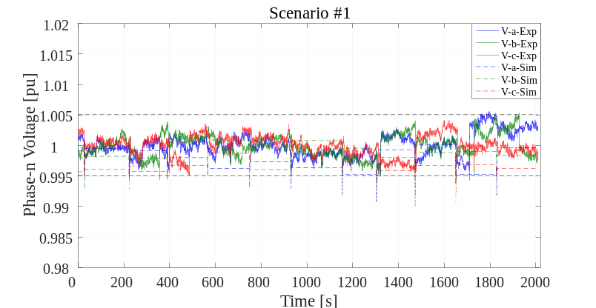
Figure 1.1. This is an example of a figure caption: the font size is 10 points, the caption paragraph is justified, indented by 1.5 cm on both ends, the line spacing is 12 points, the text style is “Figure Caption”.
In the case a figure is provided in a list of graphic files attached to the thesis, the name of the file should also be printed (in a small font) in the bottom left-hand corner. This makes it easier to find this file among the list of graphic files to be included in the final version of the Thesis. If the text is overburdened with figure data, these should be included in one or more Appendices at the end of the Thesis.
It may sometimes be necessary to arrange two or more figures on the same line in order to be able to easily compare the respective graphs. This is the case, for example, of Figure 1.2, in which a Figure 1.2a and a Figure 1.2b can be seen.
The thickness of the continuous and dotted lines that appear in a figure must be appropriate. The lower thickness limit is 2 points. The symbols used (circles, squares, triangles, ...) must have a minimum size of 12 points. Using smaller thicknesses or sizes means running the risk of making lines or symbols illegible when the size of a figure is reduced with respect to the original. A situation where a figure appears at the bottom of the page and the corresponding caption is featured on the next page must be absolutely avoided.

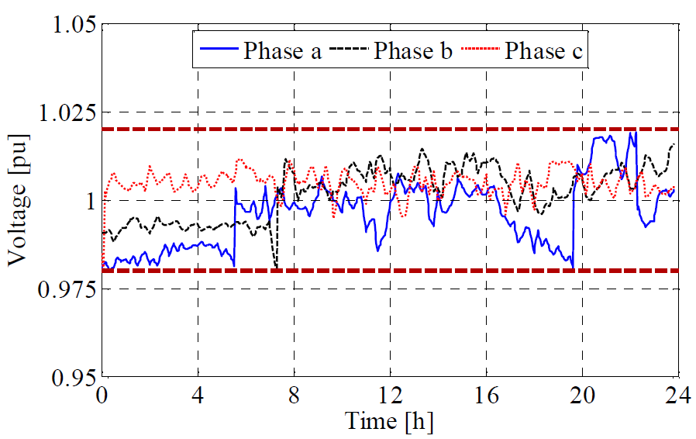 | 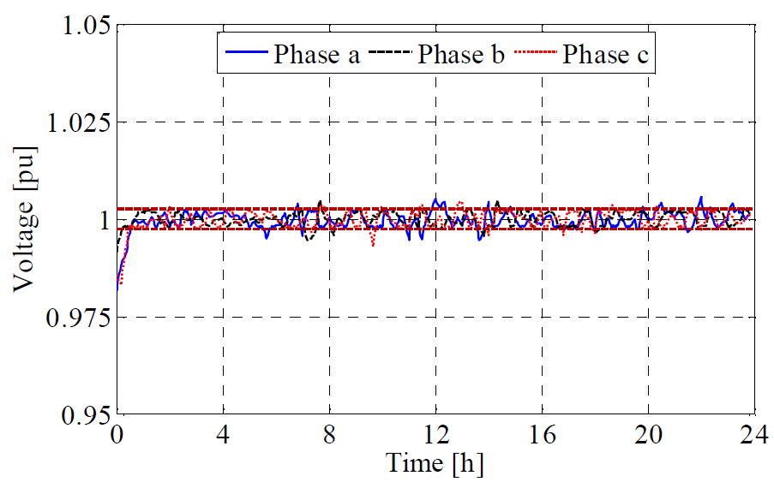
a) | b)
Figure 1.2. In this case, the two figures have been placed side by side so that (a) represents a given situation, and (b) represents another.
Sometimes a figure is not created independently, but it is borrowed from another source (an article, book or website). In this case, the source must be specified in the caption of the figure (you can use a quotation like in a bibliographical reference).

1.2.1.1 On the reproduction of results
We mentioned earlier that it must be possible for anyone to reproduce all the results shown in the figures even after the Thesis has been completed. If these results were obtained using the mathematical model of a process, the name of the calculation code used and all code input data must always be specified. In order not to make the text too cumbersome, these indications are usually provided for each figure in an Appendix which appears after the Conclusions of the Thesis (and before the Bibliography).
If, on the other hand, the results shown in a figure come from experimental tests, the operating conditions for the tests (e.g. barometric pressure, operating temperature, power composition, initial holdups, controller parameters, etc.) must be specified.

1.2.2 Let's finish with the tables
The font size of the text appearing in a table must be smaller than the size of the body text. In general, a size of 10 points is recommended. A typical example is shown in Table 1.1. Please note that in this case the caption should be placed above the table. Due to the small font size, the spacing between the rows of the table is smaller than that used for the body text (a line spacing of 14 points can be used); in addition, the columns have a width adapted to the text contained and the header row is shown in bold. Please note that all quantities reported have their own unit of measurement.
Table’s external edges should only be used on upper and lower margins, not laterally. External edges should be heavier than internal ones and the headers row separated by the rest of the table by an edge lighter than the external one. In the example in Table 1.1, the external and inner edges have weights 1.5 pts and 1 pt, respectively. Vertical edges can be used if deemed necessary (e.g., for long tables or in the case of multiple columns grouped, like in Table 1.1) and, in such case, should have a smaller edge weight (in the shown case, 0.5 pts). Although the background color should be neutral, other colors could be used, if deemed necessary for results explanation.
For decimal numbers, the decimal point must be used, not the comma which is, instead, used for thousands separation. Care should be taken to use a reasonable number of digits after the decimal point to give an indication of the precision with which the quantity in question is measured or calculated.
You must absolutely avoid “splitting” a table in two, with one section at the end of the page and the other at the beginning of the next page.
A paragraph (or a sub-paragraph) should never end with a table (or a figure, or an equation). In order to improve the paragraph’s graphic appearance, it is advisable to add even just a couple of lines of text below a table.
Table 1.1. This is an example of a table caption. Except for the position in relation to the table, the caption is entirely similar to that used for the figures; the style of the paragraph is “Table caption”.
R_{gr} [Ω] | Total losses [kWh] |  | Transformer losses [kWh] |  | Lines losses [kWh]
1000 | 8,837.1 | - | 3,608.2 | - | 5,228.9 | -
100 | 8,616.4 | (-2.50 %) | 3,607.0 | (-0.03 %) | 5,009.4 | (-4.20 %)
50 | 8,525.1 | (-3.53 %) | 3,606.5 | (-0.05 %) | 4,918.6 | (-5.93 %)
10 | 8,396.6 | (-4.98 %) | 3,605.9 | (-0.06 %) | 4,790.6 | (-8.38 %)
5 | 8,345.4 | (-5.56 %) | 3,605.8 | (-0.07 %) | 4,739.5 | (-9.36 %)
1 | 8,249.8 | (-6.65 %) | 3,605.8 | (-0.07 %) | 4,644.0 | (-11.19 %)

1.3 Calculation codes
Sometimes it is appropriate to describe certain lines of calculation codes in detail to make it easier to interpret them. In these cases, the font to be used is 10-point Courier New, with a line spacing slightly smaller than that used for the rest of the text. For example, if you want to describe how the control law (1.2) is implemented, you could use a script like this:

if h==1:
model.addConstr(E[h]==SOC_0*Emax-E_out[h]+E_in[h])
elif h==24:
model.addConstr(E[h-1]-E_out[h]+E_in[h]==SOC_0*Emax)
model.addConstr(E[h]==SOC_0*Emax)
else:
model.addConstr(E[h]==E[h-1]-E_out[h]+E_in[h])

If you quote a variable within the text with the name assigned to it in the algorithm listing, you should still use the Courier New font, albeit not in italics. An example is if the name RIFL is used to denote the quantity which in (1.2) is denoted by L. The complete listing of the calculation code can be found in Appendix A. This has nothing to do with it, but it is worth saying that you can also make use of footnotes, albeit very sparingly, to add a few more details or give some other kind of comment). In the same Appendix, the user manual for the program must be included. It is generally sufficient to report the data file and indicate “which-variable-goes-where”.
In general, appendices are chapters of the Thesis provided after the references where the author adds more information about a specific feature discussed in the text, for example providing datasets or scripts that support the synthetic discussion provided in the document.

1.4 References
Concerning references, the IEEE format should be used, as further specified by the instructions below.
References need not be cited in text. When they are, they appear on the line, in square brackets, inside the punctuation. Multiple references are each numbered with separate brackets. When citing a section in a book, please give the relevant page numbers. In text, refer simply to the reference number. Do not use “Ref.” or “reference” except at the beginning of a sentence: “Reference [3] shows ... .”
Reference numbers are set flush left and form a column of their own, hanging out beyond the body of the reference. The reference numbers are on the line, enclosed in square brackets. In all references, the given name of the author or editor is abbreviated to the initial only and precedes the last name. Use them all; use et al. only if names are not given or if there are more than 6 authors, as in [3].
Use commas around Jr., Sr., and III in names. Abbreviate conference titles. When citing IEEE Transactions, provide the issue number, page range, volume number, month if available, and year. When referencing a patent, provide the day and the month of issue, or application. References may not include all information; please obtain and include relevant information. Do not combine references. There must be only one reference with each number. If there is a URL included with the reference, it can be included at the end of the reference.
Other than books, capitalize only the first word in an article title, except for proper nouns and element symbols. For articles published in translation journals, please give the English citation first, followed by the original foreign-language citation.
Some examples of references can be found at the end of the document, where the “References” chapter should be placed. In particular you can find references about: a peer-reviewed conference paper [1] , scientific journal papers [2] [3] , a book [4] , a Ph.D. Thesis [5] , a technical standard [6] and an online report [7] . A list of accessed websites can be provided as well, specifying the last access date.

1.5 Page numbering and binding margins
Pages should be numbered consecutively, with Arabic numerals, from the first page of the Introduction to the last page of the Bibliography (which conclude the Thesis, and should be inserted after any Appendices and after the Nomenclature). The font to be used is 10 points in size, and the numbering starts on the right-hand page. Since the Thesis will be printed double-sided, odd page numbers will always be on the right and even numbers will appear on the left. If a Chapter ends with a right-hand page, a blank page must be inserted on the left in order to be able to start the next Chapter with a right-hand page. The presence of the blank page must be taken into account for page numbering, but the page number will not be printed on this page. The page number is also not printed on the first page of each chapter and section (Summary, Introduction, Conclusions, etc.). The number and title of the Chapter must also be added as a header to each page (the latter should be in italics, also in 10-point font). Observe how this Note is written to understand how to set headers.
As for binding margins, values can be roughly as follows: top, 3 cm; bottom, inner, outer: 2.5 cm; edge distance (header), 1.7 cm; edge distance (footer), 1.3 cm. In any case, it is best to ask for confirmation at the bookbinder where you will have your Thesis bound. Please bear in mind that the margins left for inner binding must alternate (one page on the right and one on the left).

1.6 Title page and final print
The format for the title page of the Thesis is available in a separate file. It should be emphasised that the use of the seal and logo of the University of Padua is governed by specific University regulations. In particular, the seal and the logo may not be reproduced individually, or with non-standard fonts or colours; they may not be altered in any way, nor used as patterns or superimposed on non-homogeneous backgrounds that might compromise their legibility.
The final print of the Thesis must be made in double-sided format. For rules concerning the number of hard or digital copies to be submitted, please see the website of your Degree Course.

Conclusions
The Thesis ends with a Conclusions section where all the work carried out is briefly summarised, recalling the goals, describing the techniques used, reporting any difficulties encountered, highlighting the results obtained and the limitations of the study, and suggesting possible future developments. The Conclusions section should therefore be more extensive than the Summary, and is usually 1-2 pages long.

Nomenclature

R_{i} | = | DC resistance of conductor i [Ω]
R_{e} | = | Resistance of the earth-return path [Ω]
D_{e} | = | Earth-return path distance [m]
r_{i} | = | Radius of conductor i [m]
d_{ij} | = | Mutual distance between conductors i and j [m]

Greek letters

α | = | (description of parameter α) [unit of measurement]

Acronyms

RES | = | Renewable Energy Sources
BESS | = | Battery Energy Storage System
IAE | = | Integral of Absolute value of Error

References
- C. Long, J. Wu, C. Zhang, L. Thomas, M. Cheng and N. Jenkins, "Peer-to-peer energy trading in a community microgrid," 2017 IEEE Power & Energy Society General Meeting, Chicago, IL, 2017, pp. 1-5
- M. Nick, R. Cherkaoui, and M. Paolone, “Optimal siting and sizing of distributed energy storage systems via alternating direction method of multipliers,” Int. J. Electr. Power Energy Syst., vol. 72, pp. 33–39, Mar. 2015
- Z. Lin et al., "An efficient optimization method for large-scale power systems," IEEE Transactions on Power Systems, vol. 31, no. 4, pp. 2891-2902, July 2016
- Westinghouse Electric Corporation (Staff of Technology and Science, Aerospace Div.), Integrated Electronic Systems. Englewood Cliffs, NJ, USA: Prentice-Hall, 1970
- J. Jia, "Assessment of short circuit power and protection systems for future low inertia power systems," Ph.D. Thesis, Dept. Elect. Eng., Tech. Univ. Denmark, Lyngby, Denmark, 2018
- Department of Energy & Climate Change, OFGEM, “Smart grid vision and routemap,” 2014. [Online]. Available: https://www.ofgem.gov.uk/electricity/distribution-networks/forums-seminars-and-working-groups/decc-and-ofgem-smart-grid-forum
- Requirements for generating plants to be connected in parallel with distribution networks - Part 1: Connection to a LV distribution network above 16 A, CENELEC Standard TS 50549-1, 2015

Websites:
http://www.ieeexplore.ieee.org/ (last access: 21/03/2026)
http://www.howstuffworks.com/ (last access: 19/06/2026)

Appendix A: Complete algorithm
A more detailed version of the script provided in the text can be put here for completeness.

...
if h==1:
model.addConstr(E[h]==SOC_0*Emax-E_out[h]+E_in[h])
elif h==24:
model.addConstr(E[h-1]-E_out[h]+E_in[h]==SOC_0*Emax)
model.addConstr(E[h]==SOC_0*Emax)
else:
model.addConstr(E[h]==E[h-1]-E_out[h]+E_in[h])
...
...

The Chair of the Master's Degree Programme in Electrical Engineering will kindly welcome any error reports or suggestions for the improvement of this document

