Master Degree in Computer Engineering 2023/2024

All regularly enrolled students can obtain their final degree after successfully passing the final evaluation of a series of activities accounting to a total of at least 120 CFU. Each personal training path has to be clearly specified in advance through the so-called “Individual Study Plan”, which has to be directly proposed by each student and it must comply with all national and local regulations. The submission of the Individual Study Plan is via an online submission system which is designed to help in following the mandatory constraints while highlighting what are (and their extent of) the possibilities of free choices. You are expected to submit your individual study plan as soon as possible: its acceptance does confirm you will be awarded the Master Degree as soon as you successfully pass all the chosen activities.

In order to help you in the process of submitting your Individual Study Plan, we have written this short guide that will hopefully clarify the main rules for producing a suitable Individual Study Plan. While preparing your Individual Study Plan you can refer to all the official documentation, mainly the so-called “Regolamento Didattico”.
https://didattica.unipd.it/off/2023/LM/IN/IN2547

In general, the structure of a Study Plan of the Master Degree in Computer Engineering is the same for all the curricula, and it is divided in the following main parts:

- Core competencies: three courses that are compulsory and shared among all the curricula (for a total of 24 CFU).
They are:
  - Automata, Languages and computation 9 CFU
  - Machine Learning 6 CFU
  - Operations Research 1 9 CFU

- Mandatory (core) courses: these courses characterize each curriculum and are different, in number and CFUs, for each curriculum. As the name says, they are “mandatory”.
The courses are, divided for each curriculum:
- Curriculum Artificial Intelligence and Robotics (a total of 33 CFU)
  - Artificial Intelligence 9 CFU
  - Computer Vision 9 CFU
  - Deep Learning 6 CFU
  - Intelligent Robotics 9 CFU
- Curriculum Bioinformatics (a total of 27 CFU)
  - Inferential Statistics 6 CFU
  - Bioinformatics 9 CFU
  - Computational Genomics 6 CFU
  - Learning from Networks 6 CFU
- High Performance and Big Data Computing (a total of 30 CFU)
  - Inferential Statistics 6 CFU
  - Parallel Computing 9 CFU
  - Big Data Computing 6 CFU
  - Advanced Algorithm Design 9 CFU
- Web Information and Data Engineering (a total of 33 CFU)
  - Computer Networks 9 CFU
  - Search Engines 9 CFU
  - Web Applications 6 CFU
  - Graph Databases 9 CFU

- Elective courses: they represent a set of course you can freely choose until you reach a minimum number of CFU (the minimum varies across curricula). In this way you can personalize your training path.
They are, divided for each curriculum:
- Curriculum Artificial Intelligence and Robotics (18 CFU)
  - Big Data Computing 6 CFU
  - Robotics and Control 1 9 CFU
  - Neurorobotics and Neurorehabilitation 6 CFU
  - Learning from Networks 6 CFU
  - Natural Language Processing 6 CFU
  - 3D Data Processing 6 CFU
- Curriculum Bioinformatics (24 CFU)
  - Big Data Computing 6 CFU
  - Deep Learning 6 CFU
  - Search Engines 9 CFU
  - Web Applications 6 CFU
  - Distributed Systems 9 CFU
  - Natural Language Processing 6 CFU
- High Performance and Big Data Computing (21 CFU)
  - Artificial Intelligence 6 CFU
  - Deep Learning 6 CFU
  - Search Engines 9 CFU
  - Computer Networks 9 CFU
  - Distributed Systems 9 CFU
  - Computers and Network Security 6 CFU
  - Learning from Networks 6 CFU
- Web Information and Data Engineering (18 CFU)
  - Software Platforms 6 CFU
  - Distributed Systems 9 CFU
  - Concurrent and Real Time Programming 6 CFU
  - Computers and Network Security 6 CFU
  - Computer Engineering for Music and Multimedia 6 CFU
  - Natural Language Processing 6 CFU

- Other choices: You have to choose a number of courses for 12 CFU. For each curriculum, we published three lists of courses for “other choices”, you are free to choose any course from any list for a total of 12 CFU. These courses allow you to explore subjects of areas different from those required from the chosen curriculum.
- Others: these are mandatory activities like the final project, the language proficiency test, and the internship/research training, for a total of 33 CFU.

In case you believe the proposed schema does not fit your interest and you want to submit an Individual Study Plan that does not strictly follow the constraints on the number of CFU indicated above, you may submit a “free” study plan, together with a written statement that explains the motivations for this plan. In this situation, a committee will evaluate your proposal and decide if it is coherent and admissible with the Master Degree in Computer Science.

To be valid, the Study Plan must have at least 120 CFU credits.

An example of the steps you will see on Uniweb
(example for High Performance and Big Data Computing)

Step 1: Choose “Study plan” from the menu (top right)

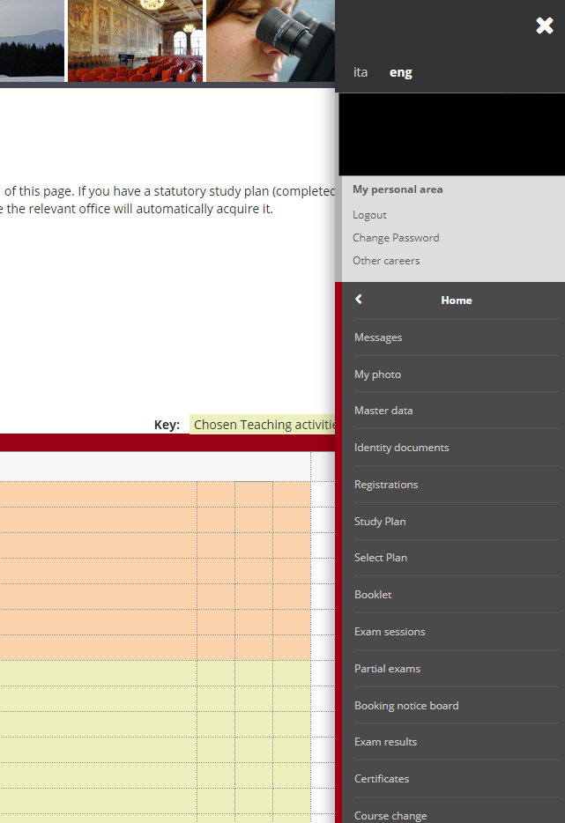

Step 2: Choose the type of plan: AUT (almost automatic approval), PRO (needs approval)
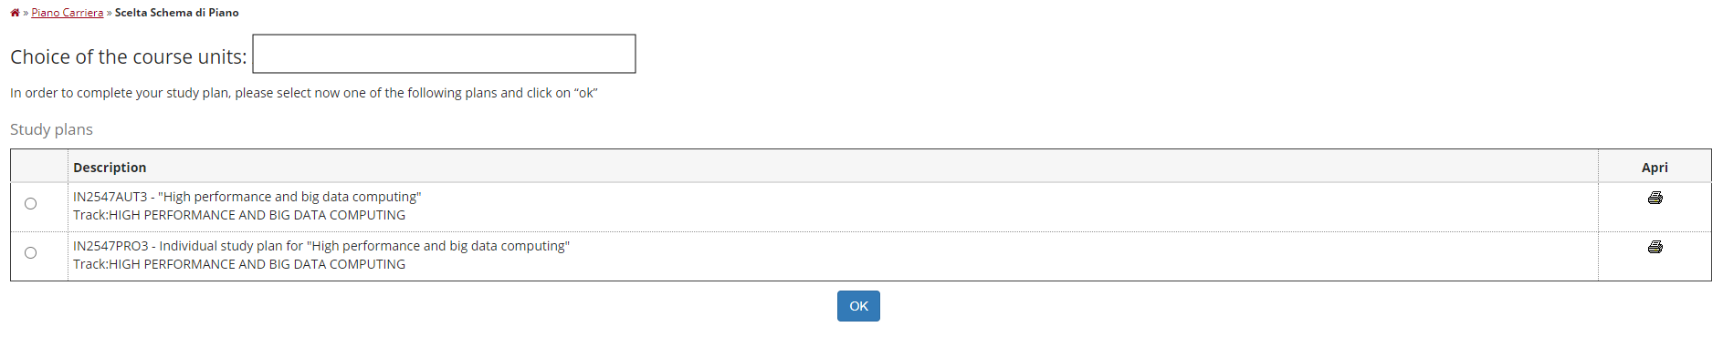

Step 3: Check compulsory educational activities (core + mandatory)
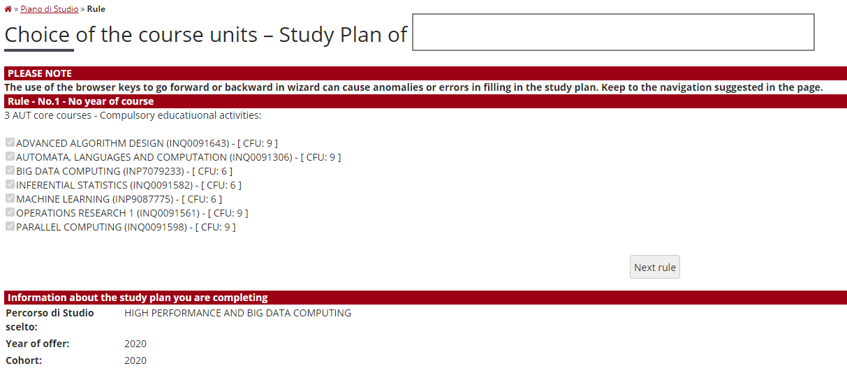

Step 4: Choose elective courses
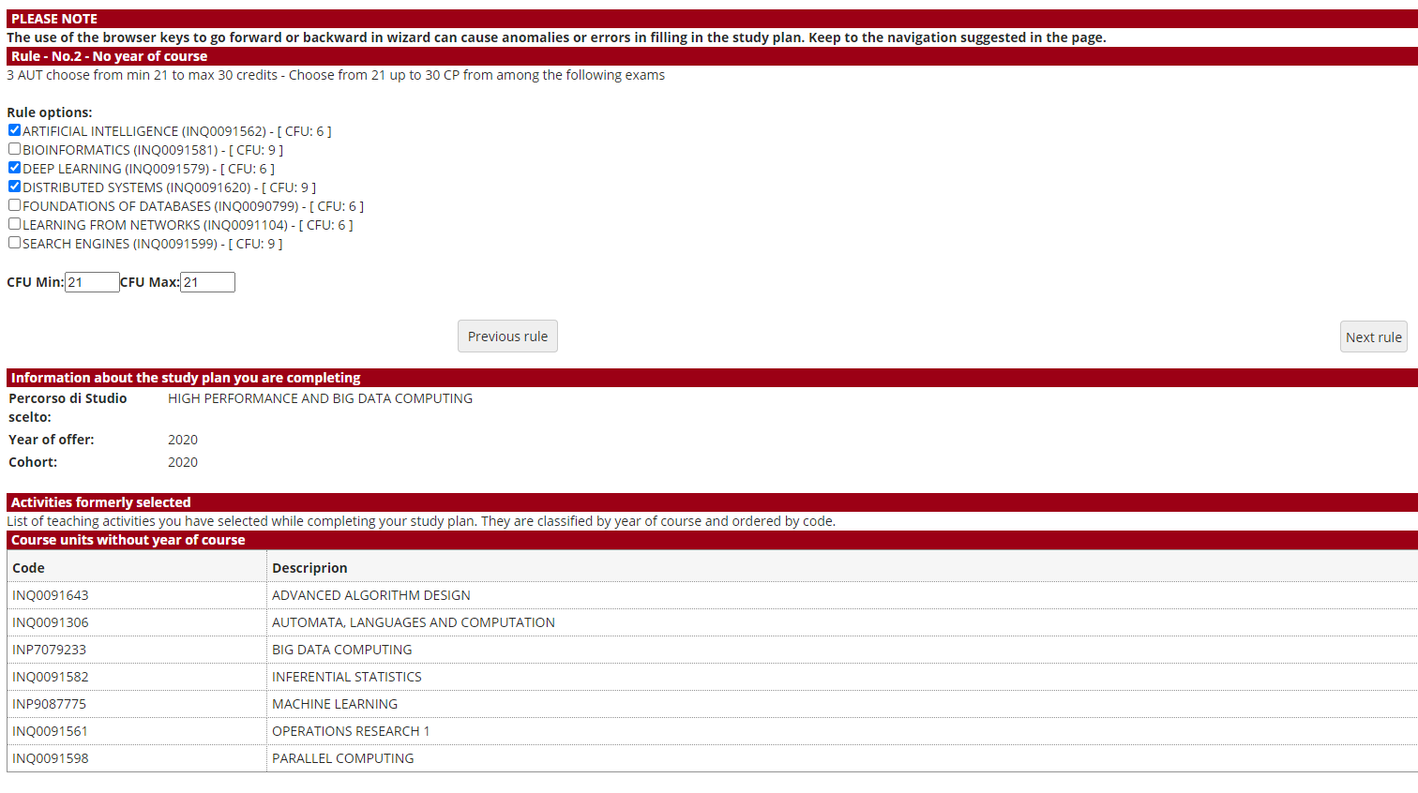

Step 5: Choose “other” courses
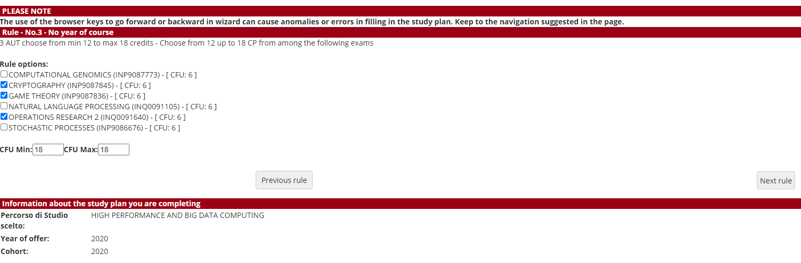

Step 6: Language proficiency (English for Italian students, Italian for international students)
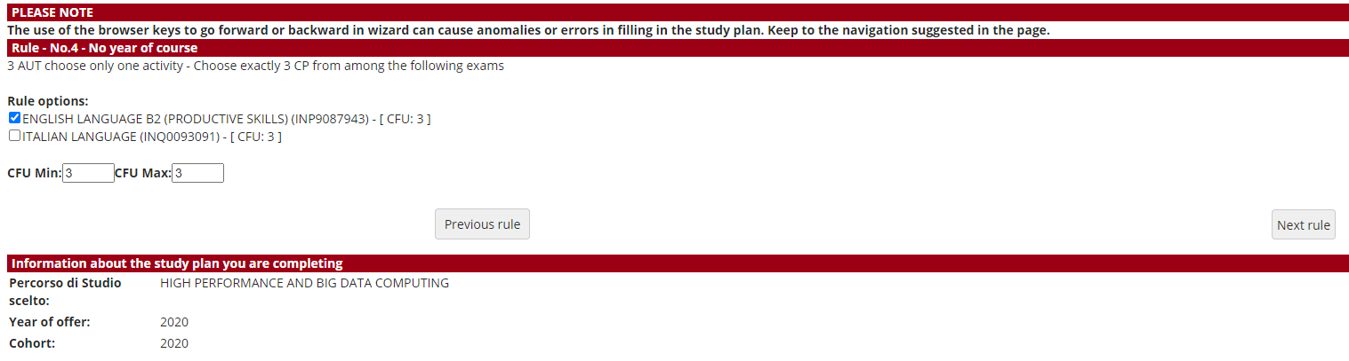

Step 7: Choose Internship or research training
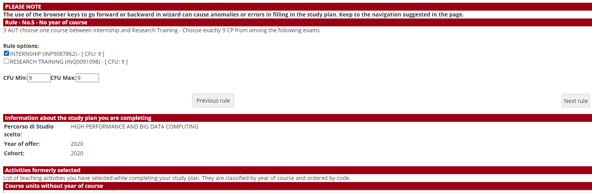

Step 8: Check final project
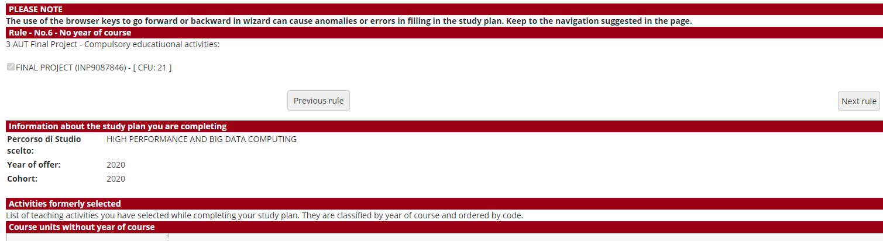

Step 9: Submit study plan
