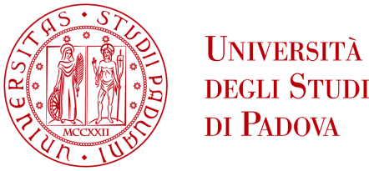
UNIVERSITA’ DEGLI STUDI DI PADOVA
Dipartimento di Ingegneria Industriale DII
Dipartimento di (add the name of the supervisor's Department ONLY if your supervisor belongs to a different Department)
Corso di Laurea Magistrale in Chemical and Process Engineering

Master’s Thesis Title

Relatore: Prof. (or Dott. or Ing.) Name Surname
Correlatore: Prof. (or Dott. or Ing.) Name Surname

Insert the name of your Supervisor here. If you have a Co-supervisor, add their name in the Correlatore section

Studente e n. matricola
(your Name, Surname, matriculation number)

Anno Accademico 202./202.

The correct academic year is the one stated in the convocation notice of the Master’s Degree session.

