
UNIVERSITÀ DEGLI STUDI DI PADOVA

Cover page template
DIPARTIMENTO DI INGEGNERIA INDUSTRIALE

If your supervisor belongs to a different department, add below the name of the supervisor's department
CORSO DI LAUREA MAGISTRALE IN CHEMICAL AND PROCESS ENGINEERING

Tesi di Laurea Magistrale in
Chemical and Process Engineering

Insert the Thesis title here

Notes on the graphic style to be used when writing Bachelor's and Master's Degree dissertations

Relatore: Prof. (or Dott. or Ing.) Name Surname
Correlatore: Prof. (or Dott. or Ing.) Name Surname

Insert the name of your Supervisor here. If you have a Co-supervisor, add their name in the Correlatore section

Insert your name here

Laureando(a): NAME SURNAME

ANNO ACCADEMICO 202? – 202?

The correct academic year is the one stated in the convocation notice of the Bachelor’s/Master’s Degree session.
Ultima revisione: 16/12/2025 16.00

Abstract
In this Note, some indications on how to write a dissertation (both for a Bachelor's and Master's Degree) are provided. The indications provided largely disregard both the “content” and the “writing style” of the dissertation. They rather concern issues such as (for example) the choice of font for the body text and titles, page layout, writing standards for equations, the arrangement of figures, tables and captions, and the citation of references.
The text is written according to the guidelines that must be adopted to write the Dissertation, therefore viewing it can provide an indication of the layout that you need for your Dissertation. In this regard, we advise you to print this Note double-sided, so that you get a document with an overall graphical appearance that is similar to that of your Dissertation.

Declaration of usage of generative AI and AI-assisted technologies
(choose between options A or B, then add the following accountability statement)

A) No generative AI and AI-assisted technologies were used to perform this project and to write the Thesis.
B) If AI or AI-assisted technologies were used, the student is required to describe any use of them, e.g.:
− executing parts of the project (including coding)
− interpreting results
− reviewing scientific and technical literature
− drawing plots and pictures
− writing text
− etc.
The author reviewed and edited the Thesis as needed and take full responsibility for its content.

Table of Contents
Introduction……………………………………………………………………………. 1
Chapter 1 − Writing the Dissertation (version 5.6).......................................................... 3
1.1 Font to be used………………………………………………………………………... 3
1.1.1 Line spacing (and other issues).............................................................................. 3
1.1.1.1 Chapters, paragraphs and sub-paragraphs………………………………… 5
1.2 Figures and tables……………………………………………………………………... 5
1.2.1 Let's start with figures…………………………………………………………… 5
1.2.1.1 On the reproduction of results…………………………………………….. 7
1.2.2 Let's finish with the tables………………………………………………………. 8
1.3 Calculation codes……………………………………………………………………... 9
1.4 References……………………………………………………………. 9
1.4.1 Quotation by author……………………………………………………………... 9
1.4.2 Quotation by number…………………………………………………………... 10
1.5 Page numbering and binding margins……………………………………………… 11
1.6 Title page and final print……………………………………………………………. 12
Conclusions……………………………………………………………………………. 13
Nomenclature………………………………………………………………………………..15
References (first style, to be preferred).................................................................................17
References (second style)........................................................................................................ 20

Introduction

Use the style “Chapter Number”
The Dissertation's Introduction summarises the reasons for studying a particular topic, placing them in the national and international scientific context, or taking into account the context of the company in which the study was conducted. After the reasons, the goals of the Dissertation should be stated; next, information should be given on the structure of the Dissertation, briefly indicating the number of Chapters and the content of each Chapter. Normally, the Introduction is not very long (a couple of pages are usually enough), but we invite you to check with your supervisor for more specific guidance.
Please note that the Dissertation includes the Introduction, therefore the Introduction appears in the Table of Contents. However, a Summary of the Dissertation must be included before the Table of Contents. In no more than twenty lines, you are required to provide a summary of the issue that the Dissertation deals with, the tools or methods used to solve it, the results achieved, and the limitations of the study. This Note consists of a single Chapter, and therefore only one Chapter will appear in the Table of Contents. A Dissertation will instead consist of several Chapters, and each of them must appear in the Table of Contents under its own title.
It is worth noting that the Dissertation should be written by adopting a scientific style: the first person should therefore never be used (“I conducted an analysis of the data”; “we obtained interesting results”), and a corresponding impersonal form (“an analysis was conducted”; “interesting results were obtained”) should be always preferred.

Chapter 1

Use the style “Chapter title”

Use the style “Chapter Number”
Writing the Dissertation
(version 5.6)
Normally, at the beginning of a Chapter there is a short preamble (5-6 lines) summarising the topics that will be discussed in the chapter.

This title level should be in the style “Heading 1”

1.1 Font to be used

For the text body, use the style “Normal”
The font to be used for the body text is Times New Roman, 12 points. The body text should be written in a plain font, like the one that you are reading now. Italic writing is generally used in two cases: to emphasise certain concepts, or to indicate foreign technical terms that are not currently in use in the language that you are writing in (in this case, English). In the first case, it is always preferable not to use an excessive number of italicised terms, so as not to compromise the readability of the text. As for the second case, it is best to avoid using a foreign term when it is possible to translate it with a corresponding English term.

For this title level, use the style “Heading 2”

1.1.1 Line spacing (and other issues)
Line spacing must be set exactly at 18 points, which corresponds to slightly less than 1.5 lines. Exact line spacing allows to insert an equation in the body text (as is the case when, for example, you write that ) without causing mismatches between the line containing the equation and the other lines.
Speaking of equations, all equations that appear as “stand-alone”, i.e. not within the body text, must be numbered. By equations we mean both the actual mathematical formulas (equations; inequalities; etc.), but also stoichiometric equations, kinetic mechanisms and chemical formulas. The numbering of equations must be consecutive, by Chapter, and placed at the right-hand margin of the page. Consider this example, which also clarifies the spacing to be used between the body text and the equation. The first equation of the Chapter is:

Style “Equation”, with manual addition of a tabulation

, (1.1)

while the second is:

. (1.2)

The equations (1.1) and (1.2) are also useful to make the following observations:
- variables, even if superscript or subscript, always go in italics; matrices and vectors (which should not be written in italics, but in bold) and Greek letters and numbers (which go in plain text, i.e. not in italics) are exceptions to this rule;
- differential symbols, like all function symbols (e.g. that of the natural logarithm), should not be written in italics;
- punctuation is still necessary and must be placed next to formulas.
When a variable is used within the body text and not inside of an equation, the same style used for equations applies.
The first time a symbol is introduced into a text or equation, that symbol must be defined, along with its unit of measurement. For example, immediately after writing (1.1) one should specify that R (kmol) represents the amount of residue, A (kmol) the amount of feed, and x_{D} and x_{R} the molar fractions of volatile components in the distillate and residue (respectively). A similar description should also be provided for the symbols that appear in (1.2). All symbols used in the Dissertation are collected and described in a Nomenclature section that is included before the References.

For this title level, use the style “Heading 3”

1.1.1.1 Chapters, paragraphs and sub-paragraphs
The Chapter number must be written in Times New Roman font, bold, 28 points, centred on the page. The Chapter title is of the same type, but the font size is slightly smaller (e.g. 25 points); if necessary, the title can be written in several lines, appropriately spaced.
All paragraphs and sub-paragraphs must be numbered. If they need to be recalled in the text, the § symbol must be used. Paragraph titles (e.g. the title of §1.1) should be in bold, 14-point Arial font; sub-paragraph titles (e.g. §1.1.1) should be in italics, and always in the same font. Only in case it is absolutely necessary, sub-sub-sections may be used (such as this §1.1.1); in this case, the font is 12 points, underlined.
White space should be left between the title and body of the paragraph, as seen in this Note, but the title of a paragraph or sub-paragraph should never form the last line of a page. It is convenient to set a “style” in Microsoft Word for the titles of chapters, paragraphs and sub-paragraphs, so that the subsequent automatic structuring of the Dissertation’s table of contents will be much easier. One of the advantages of using a style template is that white space to be left before and after a title is automatically incorporated into it, so that inserting blank lines is no longer necessary.

1.2 Figures and tables
Figures and tables should be numbered consecutively but independently. For example, you could have a Figure 2.1, but at the same time also a Table 2.1. Numbering is assigned by first specifying the Chapter number, and then the sequential number of the figure or table in that Chapter. The preceding lines also illustrate when to use upper or lower case letters to quote a figure or table within the body text.

1.2.1 Let's start with figures
Since the next figure is the first to appear in this chapter, it should be referred to as Figure 1.1. As you can see, the figure is centred in relation to the text and it is provided with a caption, which must be “self-sufficient” for the complete description and understanding of the figure (i.e. it must not be necessary to read in the body text either what the figure represents or which parameters, if any, characterise that figure).
The figure should be placed as close as possible to the point in the text where it is first recalled. Sometimes, however, it may be necessary to move the figure a little further forwards or backwards than where you would like to place it, to avoid the mismatch of the lines of text.
As you can see in Figure 1.1, axis captions should be written in full, i.e. without abbreviations or the use of symbols; the units of measurement of the quantities represented should also be specified. A fairly large font (e.g. 32 points) should be used for all written text inside and outside the graph, so that the subsequent reduction of the figure, when pasted into Word, does not make it difficult to read it.

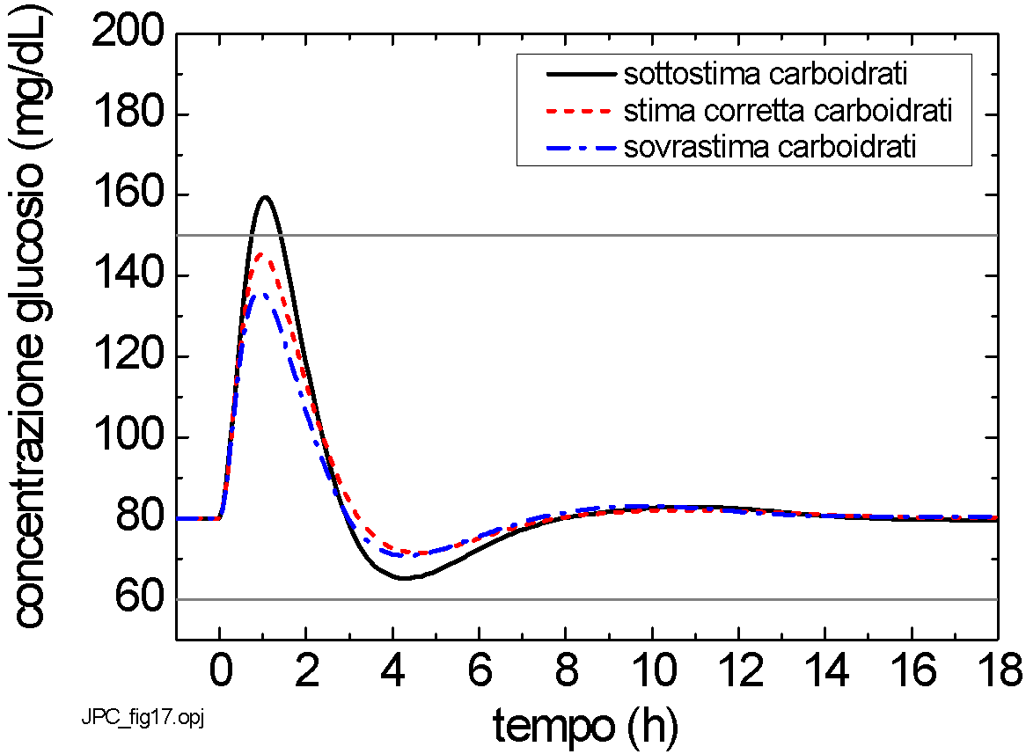
Figure 1.1. This is an example of a figure caption: the font size is 10 points, the caption text is centered with respect to the body of the paragraph, the line spacing is 12 points, the text style is “Figure Caption”
You can also see that the name of the figure's source file appears (in small print) in the bottom left-hand corner. This makes it easier to find this file among the list of graphic files to be included in the final version of the Dissertation. All figures must be supported by the necessary data to reproduce the results shown at any time (and by anyone). If the text is overburdened with figure data, these should be included in one or more Appendices at the end of the Dissertation.
It may sometimes be necessary to arrange two or more figures on the same line in order to be able to easily compare the respective graphs. This is the case, for example, of Figure 1.2, in which a Figure 1.2a and a Figure 1.2b can be seen.
The thickness of the continuous and dotted lines that appear in a figure must be appropriate. The lower thickness limit is 2 points. The symbols used (circles, squares, triangles, ...) must have a minimum size of 12 points. Using smaller thicknesses or sizes means running the risk of making lines or symbols illegible when the size of a figure is reduced with respect to the original. A situation where a figure appears at the bottom of the page and the corresponding caption is featured on the next page must be absolutely avoided.

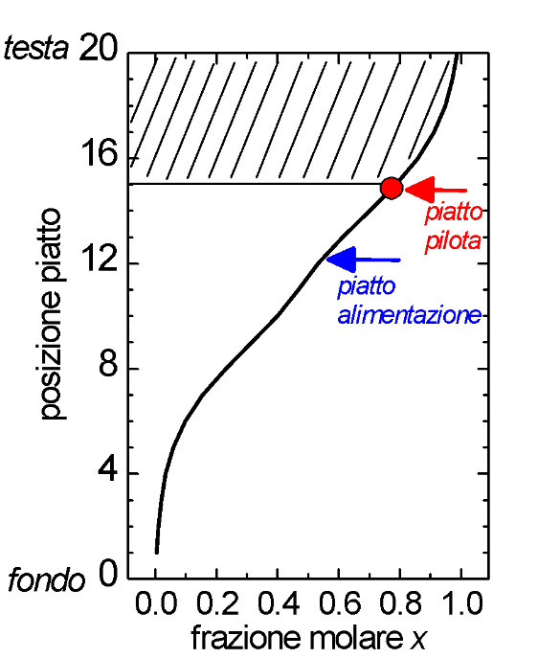
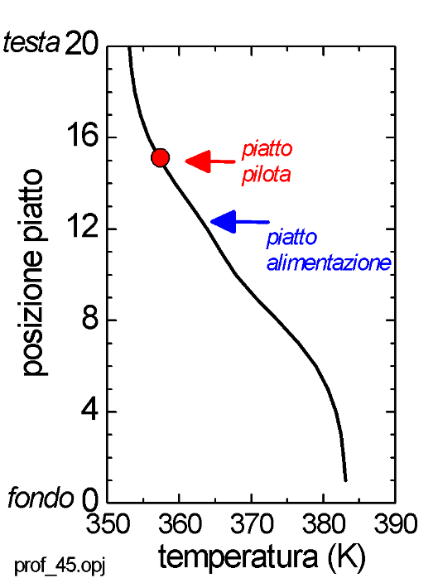

(a) (b)
Figure 1.2. In this case, the two figures have been placed side by side so that (a) represents a given situation, and (b) represents another.
Sometimes a figure is not created independently, but it is borrowed from another source (an article, book or website). In this case, the source must be specified in the caption of the figure (you can use a quotation like in a bibliographical reference).

1.2.1.1 On the reproduction of results
We mentioned earlier that it must be possible for anyone to reproduce all the results shown in the figures even after the Dissertation has been completed. If these results were obtained using the mathematical model of a process, the name of the calculation code used and all code input data must always be specified. In order not to make the text too cumbersome, these indications are usually provided for each figure in an Appendix which appears after the Conclusions of the Dissertation (and before the Bibliography).
If, on the other hand, the results shown in a figure come from experimental tests, the operating conditions for the tests (e.g. barometric pressure, operating temperature, power composition, initial holdups, controller parameters, etc.) must be specified.

1.2.2 Let's finish with the tables
The font size of the text appearing in a table must be smaller than the size of the body text. In general, a size of 10 points is recommended. A typical example is shown in Table 1.1. Please note that in this case the caption should be placed above the table. Due to the small font size, the spacing between the rows of the table is smaller than that used for the body text (a line spacing of 14 points can be used); in addition, the columns have a width adapted to the text contained and the header row is shown in bold. Please note that all quantities reported have their own unit of measurement.
For decimal numbers, the decimal point must be used, not the comma. Care should be taken to use a reasonable number of digits after the decimal point to give an indication of the precision with which the quantity in question is measured or calculated.
You must absolutely avoid “splitting” a table in two, with one section at the end of the page and the other at the beginning of the next page.

Table 1.1. This is an example of a table caption. Except for the position in relation to the table, the caption is entirely similar to that used for the figures; the style of the paragraph is “Table caption”.
V [kmol/h] | L [kmol/h] | x_{R} [-] | x_{D} [-] | t [h]
100.0 | 50.0 | 0.3751 | 0.9238 | 0.254
100.0 | 64.0 | 0.2373 | 0.9300 | 0.224
100.0 | 73.0 | 0.1240 | 0.9433 | 0.213

A paragraph (or a sub-paragraph) should never end with a table (or a figure, or an equation). In order to improve the paragraph’s graphic appearance, it is advisable to add even just a couple of lines of text below a table.

1.3 Calculation codes
Sometimes it is appropriate to describe certain lines of calculation codes in detail to make it easier to interpret them. In these cases, the font to be used is 10-point Courier New, with a line spacing slightly smaller than that used for the rest of the text. For example, if you want to describe how the control law (1.2) is implemented, you could use a script like this:

RIFLBIAS=127. ! [L/h]
ERR=VAR-VARSP
INTERR=INTERR+ERR*DELTACAMP
RIFL=RIFLBIAS+GAIN*(ERR+INTERR/TAUI)

If you quote a variable within the text with the name assigned to it in the programme listing, you should still use the Courier New font, albeit not in italics. An example is if the name RIFL is used to denote the quantity which in (1.2) is denoted by L. The complete listing of the calculation code can be found in Appendix (1. This has nothing to do with it, but it is worth saying that you can also make use of footnotes, albeit very sparingly, to add a few more details or give some other kind of comment). In the same Appendix, the user manual for the programme must be included. It is generally sufficient to report the data file and indicate “which-variable-goes-where”.

1.4 References
When it comes to references, two things must be clear: how to quote an article or text or dissertation in the body text, and how to list the different sources (journal article or conference proceedings; book or book section; dissertation or thesis) in the References.
There are two main standard styles for quoting a document from within the body text, therefore you will have to ask your supervisor which style you will be required to follow.

1.4.1 Quotation by author
According to this style (generally preferable to the second), when quoting a document from the body text, the authors' surnames (separated by “and”) and the year of publication of the document are provided, for example when quoting the text by Robinson and Gilliland (1950). The work we have just referred to is a book. The title must be written in full and in italics in the Bibliography; the reference is completed with the publisher, place of publication, and the page number to which the quotation refers.
In some cases you may be required to quote a work published in a book whose chapters were written by different authors. An example is the contribution by Häggblom and Waller (1992): please note that both the title of the book chapter and the title of the book (in italics) appear in the reference; the name of the volume editor (in the quoted example, the editor is Luyben) must also be included.
The work of Davidyan et al. (1994) and Skogestad et al. (1997) was published in a journal; the italicised “et al.” is justified by the fact that, for both publications, the number of authors is greater than two. The work of Meski and Morari (1995) was also published in a journal, but in this case both authors must be quoted explicitly (because the number of authors is not greater than two). Please note that the title of the article appears in full in a plain font, whereas the title of the journal is written in italics and in a “standardised” abbreviated form and the volume number appears in bold.
When quoting Dissertations (e.g. Seresin, 2002) or Ph.D. Theses (e.g. Bosley, 1994), the full title must be included, as well as the university at which the Dissertation or Thesis was written. Works presented at conferences are those by Furlonge et al. (1998), Meski et al. (1998), and Wittgens and Skogestad (1997a,b). Only one of these papers (Meski et al., 1998) was presented at a conference that collected the proceedings in an edited volume.
When the same authors publish several works in the same year, the works should be marked with the letters “a” and “b” (as in the work by Wittgens and Skogestad, 1997a,b).
Sometimes reference must be made to information that is not printed but has been obtained verbally. In this case, the information should be stated in the bibliography, as in the case of Gerolimetti (2004).
The bibliography must include all and only the documents corresponding to quotations made in the Dissertation; the list must be compiled in alphabetical order starting with the first author. Finally, please always bear in mind that you can quote only papers that you have actually read and own. A section of the bibliography will also list any websites referred to in the Dissertation; in this case, the date of last access should also be specified.

1.4.2 Quotation by number
According to this style, each reference is associated with a sequential number (which remains unchanged in all chapters), and the quotation of the document in the text is made by superscripting the document number, enclosed in brackets. For example, the first two references cited in §1.4.1 would be quoted in this way (^{1,2}), whereas if you wish to quote the third, you have to do it as such (³).
The standard styles for compiling the bibliography at the end of the Dissertation are the same as before, but the references are to be ordered in a numbered list, from the reference that was quoted first to the one that was quoted last, instead of being ordered alphabetically. At the end of this Note you will find two lists of bibliographic references, one for each of the two styles; of course, only one list should be included in your Dissertation.

1.5 Page numbering and binding margins
Pages should be numbered consecutively, with Arabic numerals, from the first page of the Introduction to the last page of the Bibliography (which conclude the Dissertation, and should be inserted after any Appendices and after the Nomenclature). The font to be used is 10 points in size, and the numbering starts on the right-hand page. Since the Dissertation will be printed double-sided, odd page numbers will always be on the right and even numbers will appear on the left. If a Chapter ends with a right-hand page, a blank page must be inserted on the left in order to be able to start the next Chapter with a right-hand page. The presence of the blank page must be taken into account for page numbering, but the page number will not be printed on this page. The page number is also not printed on the first page of each chapter and section (Summary, Introduction, Conclusions, etc.). The number and title of the Chapter must also be added as a header to each page (the latter should be in italics, also in 10-point font). Observe how this Note is written to understand how to set headers.
As for binding margins, values can be roughly as follows: top, 3 cm; bottom, inner, outer: 2.5 cm; edge distance (header), 1.7 cm; edge distance (footer), 1.3 cm. In any case, it is best to ask for confirmation at the bookbinder where you will have your Dissertation bound. Please bear in mind that the margins left for inner binding must alternate (one page on the right and one on the left).

1.6 Title page and final print
The title page with which this Note begins must also be used for the Dissertation. It should be emphasised that the use of the seal and logo of the University of Padua is governed by specific University regulations. In particular, the seal and the logo may not be reproduced individually, or with non-standard fonts or colours; they may not be altered in any way, nor used as patterns or superimposed on non-homogeneous backgrounds that might compromise their legibility. To avoid misuse, the seal and the logo should therefore not appear on the title page.
The final print of the Dissertation must be made in double-sided format. For rules concerning the number of hard or digital copies to be submitted, please see the website of your Degree Course.

Conclusions

Use the style “Chapter Number”
The Dissertation ends with a Conclusions section where all the work carried out is briefly summarised, recalling the goals, describing the techniques used, reporting any difficulties encountered, highlighting the results obtained and the limitations of the study, and suggesting possible future developments. The Conclusions section should therefore be more extensive than the Summary, and is usually 1-2 pages long.

Nomenclature

Use the style “Chapter Number”

A | = | amount of power supply (kmol)
K_{C} | = | controller gain (kmol/h)
L | = | backflow rate (kmol/h)
L₀ | = | nominal value of the backflow rate (kmol/h)
R | = | quantity of residue (kmol)
t | = | time (h)
V | = | steam flow rate (kmol/h)
x_{A} | = | molar fraction of light component in the supply (-)
x_{D} | = | molar fraction of light component in the distillate (-)
x_{R} | = | molar fraction of light component in the residue (-)
y | = | molar fraction of light component in vapor phase (-)
y_{sp} | = | set point of the molar fraction of light component in vapor phase (-)

Greek letters

τ_{I} | = | time of the integral action (h)

Acronyms

IAE | = | integral of absolute value of error

References
(first style, to be preferred)

Use the style “Chapter Number”
Bosley, J. R. (1994). An Experimental Investigation on Modeling, Control, and Optimization Techniques for Batch Distillation. Ph.D. Thesis, University of Texas at Austin (U.S.A.).
Davidyan, A. G., V. N. Kiva, G. A. Meski e M. Morari (1994). Batch Distillation in a Column With a Middle Vessel. Chem. Eng. Sci., 49, 3033-3051.
Furlonge, H. I., E. Sørensen e C. C. Pantelides (1998). Optimal Operation of Multivessel Batch Distillation Columns. Presentato a AIChE Annual Meeting, Miami Beach (U.S.A.), 15-20 Novembre, paper 134e.
Gerolimetti, L. (2004). Comunicazione personale.
Häggblom, K. E. e K. V. Waller (1992). Control Structures, Consistency, and Transformations. In: Practical Distillation Control (W. L. Luyben, Ed.), Van Nostrand Reinhold, New York (U.S.A.).
Meski, G. A., M. Han, N. Bekiaris e M. Morari (1998). Optimality for Batch Distillation Configurations. Edited preprints of DYCOPS-5 – 5th IFAC Symposium on Dynamics and Control of Process Systems (C. Georgakis, Ed.), Corfu (Greece), 8-10 Giugno, pp.387-392.
Meski, G. A. e M. Morari (1995). Design and Operation of a Batch Distillation Column with a Middle Vessel. Comput. Chem. Eng., 19, S597-S602.
Robinson, C. S. e E.R. Gilliland (1950). Elements of Fractional Distillation (4th ed.). McGraw-Hill Book Co., New York (U.S.A.), p.388.
Seresin, I. (2002). Indici di Controllabilità di Processo: Alcuni Esempi Applicativi. Tesi di Laurea in Ingegneria Chimica, DIPIC, Università di Padova.
Skogestad, S., B. Wittgens, E. Sørensen e R. Litto (1997). Multivessel Batch Distillation. AIChE J., 43, 971-978.
Wittgens, B. e S. Skogestad (1997a). Multivessel Batch Distillation - Experimental Verification. Presentato a Distillation and Absorption Conference ’97, Maastricht (The Netherlands), 8-10 Settembre.
Wittgens, B. e S. Skogestad (1997b). Potential Energy Savings of Multivessel Batch Distillation. Presentato a AIChE Annual Meeting, Los Angeles (U.S.A.), 16-21 Novembre.

Siti web
http://www.aidic.it/ (ultimo accesso: 13/09/2009)
http://www.howstuffworks.com/ (ultimo accesso: 06/04/2009)

References
(second style)

Use the style “Chapter Number”
- Robinson, C. S. e E.R. Gilliland (1950). Elements of fractional distillation (4th ed.). McGraw-Hill Book Co., New York (U.S.A.), p.388.
- Häggblom, K. E. e K. V. Waller (1992). Control structures, consistency, and transformations. In: Practical distillation control (W. L. Luyben, Ed.), Van Nostrand Reinhold, New York (U.S.A.).
- Davidyan, A. G., V. N. Kiva, G. A. Meski e M. Morari (1994). Batch distillation in a column with a middle vessel. Chem. Eng. Sci., 49, 3033-3051.
- Skogestad, S., B. Wittgens, E. Sørensen e R. Litto (1997). Multivessel batch distillation. AIChE J., 43, 971-978.
- Meski, G. A. e M. Morari (1995). Design and operation of a batch distillation column with a middle vessel. Computers Chem. Eng., 19, S597-S602.
- Seresin, I. (2002). Indici di controllabilità di processo: alcuni esempi applicativi. Tesi di Laurea in Ingegneria Chimica, DIPIC, Università di Padova.
- Bosley, J. R. (1994). An experimental investigation on modeling, control, and optimization techniques for batch distillation. Ph.D. Thesis, University of Texas at Austin (U.S.A.).
- Furlonge, H. I., E. Sørensen e C. C. Pantelides (1998). Optimal operation of multivessel batch distillation columns. Presentato a AIChE Annual Meeting, Miami Beach (U.S.A.), 15-20 Novembre, paper 134e.
- Meski, G. A., M. Han, N. Bekiaris e M. Morari (1998). Optimality for batch distillation configurations. Edited preprints of DYCOPS-5 – 5th IFAC Symposium on Dynamics and Control of Process Systems (C. Georgakis, Ed.), Corfu (Greece), 8-10 Giugno, pp.387-392.
- Wittgens, B. e S. Skogestad (1997). Multivessel batch distillation – Experimental verification. Presentato a Distillation and Absorption Conference ’97, Maastricht (The Netherlands), 8-10 Settembre.
- Wittgens, B. e S. Skogestad (1997). Potential energy savings of multivessel batch distillation. Presentato a AIChE Annual Meeting, Los Angeles (U.S.A.), 16-21 Novembre.
- Gerolimetti, L. (2004). Comunicazione personale.

Siti web
http://www.aidic.it/ (ultimo accesso: 13/09/2009)
http://www.howstuffworks.com/ (ultimo accesso: 06/04/2009)

This Note was prepared by Prof. Massimiliano Barolo, who will kindly welcome any error reports or suggestions for improvement

